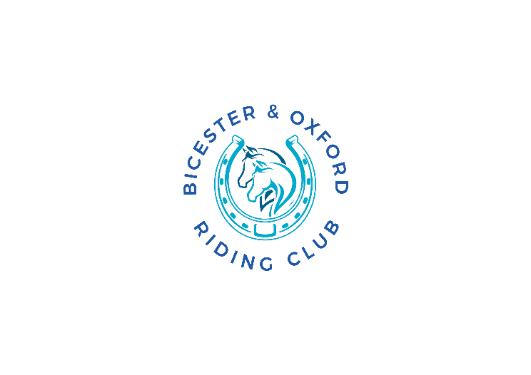
BORC Terms and Conditions for Events and Shows

By submitting your application/renewal form and payment to Bicester & Oxford Riding Club (BORC) you agree to the Terms & Conditions as set out below and in accordance with the Club’s Constitution a copy of which can be viewed on the BORC website:

1. I am a competent adult aged 18 years or older and accept sole responsibility for my own conduct and actions.

2. My involvement in the show organised by BORC is voluntary and I am acting under my own free will.
If I book an event/clinic and need to cancel I understand that the organisers do not have to give me a refund or credit, but if they agree to do so, this will be a credit against future activities minus a £5 admin fee so long as the place can be filled before entries close. thereafter no refund will be paid.
If the show has to be cancelled by the organiser they will offer a replacement date if possible or a credit against a future activity.

3. I confirm that I have no medical conditions or health concerns that make it dangerous to participate in a safe manner for myself or others.

4. I understand and agree to comply with the requirement that at all times when mounted and participating in BORC activities I must wear only approved head protection as detailed in the latest version of the British Riding Club rules and appropriate footwear.

5. I understand that if I have consented that photographs or digital recordings of me participating in riding club activities can be used for promotional purposes and my identity may be revealed therein or by description, text or commentary. I waive any rights, claims or interest to inspect or approve the use of the photograph and/or recording, and understand that there will be no financial or other remuneration of any kind.

6. I acknowledge that participation may be physically demanding and that there is risk of injury to myself or my horse/pony, including the potential for serious bodily injury, permanent disability, paralysis and loss of life. I acknowledge that such risks cannot be eliminated entirely and there is potential for risks and dangers that may not be obvious or reasonably foreseeable.

7. I confirm that I am responsible for my own safety and, where practicable, the safety of others. I understand that 100% of liability for any medical or veterinary expenses incurred because of any injury to myself or my horse/pony or property damaged during my participation in events/clinics rests solely with me and consent to receive any immediate medical treatment that may be deemed necessary in the event of injury, accident and/or illness whilst taking part.

8. I agree, to the full extent permitted by law, to waive, release, and discharge BORC, the organisers and/or landowners from any and all liability for my death, disability, personal injury, property damage, property theft or actions of any kind which may hereafter accrue to me as a result of participating in the show .

9. I confirm that I have read, understand these Terms & Conditions and will follow the guidelines established for participation and reasonable instructions given to me by BORC.

10. Any participants who are not BORC Members should hold their own insurance ( BRC Members will be covered under the club’s public liability insurance but only while competing at a Riding Club event.

11.The Organiser have the right to refuse an entry without providing a reason and have the right to alter the timetable and classes and limit the numbers of entries .

12. The Organiser have the right to cancel the event at short notice in adverse weather, if ground is considered inappropriate or because of impacts out of their control. Under such circumstances entrants will be given a full refund for their entries.

13.The Organiser may request a competitor , their connections or spectators to leave the arena and or show ground without giving a reaso but the notified persons must do so within 30 minutes of being asked to leave.

14. Any objections may be given to the Organsiers within half an hour of the event finishing with a £20 deposit . The deposit will be forefeit if not upheld and the Organisers decision is final.

