Branding Guidelines
Name:
Bicester & Oxford Riding Club reflecting roots of club
Capital B,O,R and C. Bicester always to be placed before Oxford

Can be shortened to BORC

Logo:
Depicts two horse heads symbolising ‘bi’ for Bicester and two clubs in a horseshoe
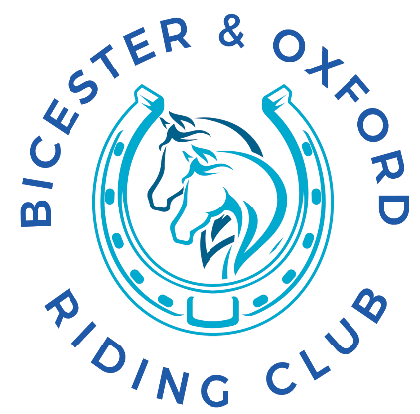

The logo can be changes in size, but individual elements of logo should not be moved around and proportions should be maintained
Fonts:
Font to be used on website and in logo is ‘Palatino Linotype’

Sizing should be :
Headers – 40pix
Sub Header – 30 pix
Copy – 20 pix

For documents and papers ‘Georgia’ may be used

Colours :
A mix of Blue and Green to represent the two founder clubs and reflect the values of Trust, dependability, strength and growth ‘popped’ with Orange for fun and friendly and Vivid green for Fresh and lively
 | Pantone | RGB | Hex | CYMK
Text
Main Colour | 312 | 0, 169, 206 | #00a9ce | 92/0/12/0
Secondary colour | 2935 | 0, 87, 183, | #0057b7 | 100/63/0/2
Third colour | 3145 | 0 ,119 ,139 | #00778b | 100/0/24/30
‘Pop’ / Spot colour 1 | 137 | 255, 164 0 | FFA400 | 0/36/100/0
‘Pop’ / spot colour 2 | 2271 | 0/187, 49 | 00BB31 | 74/0/99/0

